Mood Board for Colour:

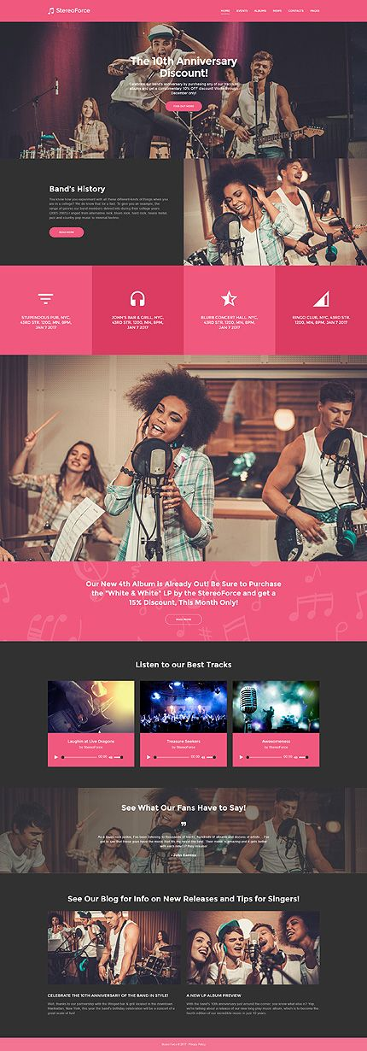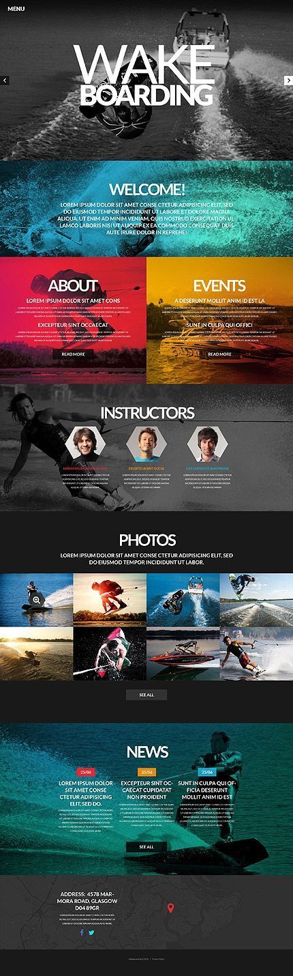I want my website to feature more colour than most music websites so I created a mood board to show different ideas of how I can make my website look more colourful.

